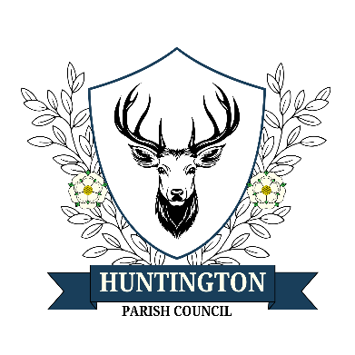
Huntington Cemetery Committee

Huntington Cemetery Rules

Rules governing Huntington Cemetery

1. All applications must be submitted using the official forms provided, accompanied by a signed copy of these rules.
2. Interments shall take place Monday to Friday between 10 a.m. and 4 p.m. Requests for interments outside of these times will be considered where possible on an exceptional basis.
3. All fees and charges due to Huntington Cemetery shall be paid to the Burial Clerk at the time that the application is made and before any work is put in hand. The Disposal Certificate (green form) must be produced before the burial takes place.
4.The fees charged are for the maintenance of the Cemetery and do not mean ownership of the land which remains the property of Huntington Parish Council.
5. Burial Plots shall be sited in rows at a distance of 5 feet between Burial Plot centres. Burial Plots shall be lettered in even numbers on the right of the roadway i.e. plot: 2,4,6. On the left of the roadway they shall be numbered in odd numbers 1,3, 5.
5b. Full sized Graves will not be available solely for the purpose of interment of Cremated remains.
6. Any application for the interment of a non-parishioner for more than 2 years at the time of death will incur non-residents charges.
6b. However, this doesn’t apply to any individual who has moved for circumstances beyond their control. Huntington Parish Council Cemetery Committee will make a decision based on a case by case basis
7. Graves shall only be dug by Grave diggers approved by the Huntington Parish Council Cemetery Committee.
8. Headstone memorials may only take the form of a headstone 525mm (21”) in width and not less than 75mm (3”) in thickness, fixed to a base which shall be 610mm (24”) in width by 300mm (12”) in depth. The total height of the memorial shall be 825 mm (33”) above the level of the foundation slab. Any additional memorial in the form of a surround will not extend beyond 610mm (24”) from the head end of the grave space or beyond the width of the grave space nor be of a height greater than 150mm (6”).
9. A tablet of dimensions 380mm (15”) in width, 150mm (6”) in depth and 300mm (12”) in height may be permitted on the designated cremated sections of the cemeteries.
Surrounds on cremated remains plots must not exceed 100mm (4”) beyond the Foundation stone and are restricted to a height of 150mm (6”).
10. Any chippings, pebbles or other permitted items must be entirely contained within such a surround. Only unbreakable flower vases which fit within the plinth / surround are permitted. Memorials which illuminate (eg, solar lights), move (eg, solar powered devices, windmills), and/or make a noise (eg, wind chimes) will be permitted within the surround.
Name (BLOCK CAPITALS):
Signature:
Date:
Name of Deceased (BLOCK CAPITALS):
Please sign and return one copy of this form with your application form. You can return both this form and the application form to the Cemetery Clerk at cemeteryclerk@huntington-pc.gov.uk or:
Huntington Cemetery, New Lane, Huntington, YO32 9LY

I have read, understood and accept the Huntington Cemetery rules regarding the application of:

Any prohibited items will only be removed by a member of the Cemetery Committee after all reasonable efforts have been made to contact the family of the deceased. This will include checking clerical records held by the Cemetery Clerk, using social media, publishing notices on the Cemetery website, and displaying a notice on the Cemetery notice board. If no family can be traced, the items will be respectfully removed and stored for three months by the Committee.
11. Seasonal decorations are permitted from 1st December each year but must be removed by 31st January or they may be collected and removed by Huntington Cemetery staff after this date.
12. A register of all burials shall be kept by the Burial Clerk and shall be made available for inspection at a convenient time for a fee.
13. All current prices for Graves, interments, Plaques etc are available on the website or from the Burial Clerk.
14.These rules are amended by Huntington Parish Council Cemetery Committee and approved by Huntington Parish Council on 12th March 2024 and they replace any other Huntington Parish Council Cemetery Committee Rules and Regulations.
15. Huntington Parish Council Cemetery Committee are not responsible for any damage which may be caused to headstones, plaques, inscriptions, trees, shrubs, or seats subject to the provisions of the Local Authorities Cemeteries Order 1977.
https://www.legislation.gov.uk/uksi/1977/204/contents/made

